YEAR 11 PHYSICS: Heat Unit Test. Name: _________________________________
(30 marks total)
Written Section.
Where appropriate, all written answers are to include the name and explanation of the physics law or phenomena illustrated in the question.

- Students in year 9 often say that heat is how hot something is. Imaging you are teaching a year 9 class, explain to them the difference between heat and temperature. They have already studied energy in general and understand the terms potential and kinetic energy. (2 marks)

____________________________________________________________________________________________________________________________________________________________________________________________________________________________________________________________________________________________________________________________________________________________________________________________________________________________________________________________________________________________________________________________________________________________________________________________________________
- While Samantha was rugged up on a cold night, she noticed that her cat’s fur seemed very fluffy. Explain why the fluffy fur would help keep the cat warm. (3 marks)

________________________________________________________________________________________________________________________________________________________________________________________________________________________________________________________________________________________________________________________________________________________________________________________________________________________________________________________________________________________________________________________________________________________________________________________________________________________________________________________________________________________________
- Matthew and Veronica are looking for floor covering. Matthew feels a tiled floor and finds it too cold. Veronica feels the carpeted floor and finds it warm. When they discuss this with the salesman, he correctly informs them that the two coverings are the same temperature. If the two coverings are the same temperature, why does the tiled floor feel cold while the carpet feels warm? (3 marks)

___________________________________________________________________________________
___________________________________________________________________________________
___________________________________________________________________________________
___________________________________________________________________________________
___________________________________________________________________________________
___________________________________________________________________________________
___________________________________________________________________________________
___________________________________________________________________________________
- 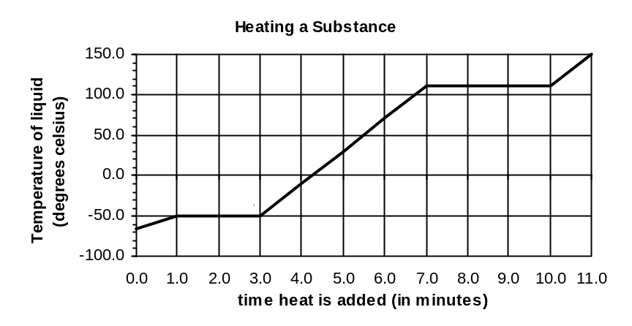A student using a bunsen burner, a thermometer, a clock and a substance in a beaker, does an experiment to obtain the following graph.

The substance starts off as 100% solid at t = 0 minutes.

a. What phase or phases is/are present between
(i) B and C? _____________________________________ (1 mark)
(ii) C and D? _____________________________________ (1 mark)

- Explain on a molecular level why the temperature doesn’t change between C and D although heat is still being added to the substance. (2 marks)

________________________________________________________________________________
________________________________________________________________________________
________________________________________________________________________________
________________________________________________________________________________
________________________________________________________________________________
________________________________________________________________________________

- Section AB is shorter than section CD. What does this indicate about the thermal properties of the substance? (2 marks)
______________________________________________________________________________________________________________________________________________________________________________________________________________________________________________________________________________________________________________________________________________________________________________________________________________________________________________________________________________________________________
__________________________________________________________________________________________________________________________________________________________________

Calculation Section:
All answers must be given to 3 significant figures

- Calculate the heat energy required to heat 0.150 kg milk (specific heat 3.90 x 10³ J kg⁻¹ K⁻¹) from 8.00 °C to 75.0 °C. (2 marks)

- The graph below shows the heating curve for 0.600 kg of a solid which has been heated in a well-insulated container by a 1.00 x 10² W heater. Calculate the specific heat of the substance in its liquid phase. (3 marks)
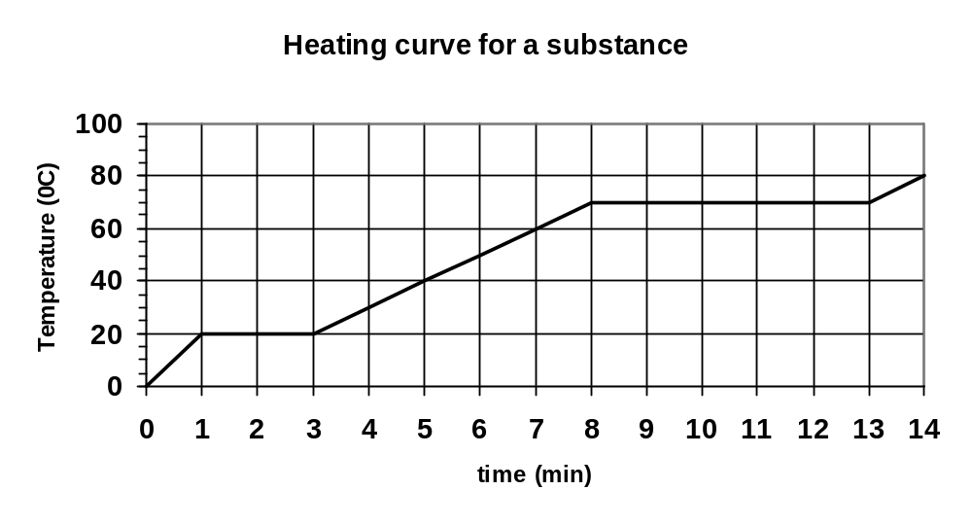

- 7.83 x 10⁵ J of heat energy is applied to ice at 0.00° C. What mass of ice will melt? (2 marks)

- 0.200 kg of steam at 108.0° C has heat energy removed until it becomes ice at –5.00° C. Calculate the amount of heat energy removed. (3 marks)

- An ice-block tray holding 0.250 kg of water at 18.0 °C is placed in the freezing compartment of a refrigerator. If it takes 1.50 hours to form ice-blocks (at 0.00 °C), at what rate (in J s⁻¹) was the refrigerator extracting heat from the water? (3 marks)

- A student adds ice at –5.00 °C to 200.0 mL of water at 80.0 °C which is in an insulated 55.0 g copper calorimeter (specific heat 380.0 J kg⁻¹ K⁻¹). After the ice has all melted, the student takes the temperature and finds that it is 25.0 °C. How much ice did the student add? Assume no heat loss to the surrounding air. (3 marks)

